Screen Time and Content Restrictions for Apple devices

Apple has inbuilt Screen Time restrictions on all its devices (iPhones, iPads, Macs), albeit you will need iOS12 or later to be installed (so it may not be an option on much older devices).

The main benefits of enabling Screen Time are to:

- Limit when devices can be used – Down Time i.e. to have them disabled between, say, 8pm until 8am. You can set a blanket restriction for every day or tailor to specific days to allow for different usage on a weekend;
- Set time limits for specific groups of apps, e.g. Social Media, Games after which time they will be blocked;
- Any apps downloaded have to be approved;
- Lock various device settings and restrict access to unsuitable websites; and
- Track overall usage to identify any patterns of use that might of concern.

Should children wish to use their devices for longer at any time, they can request access which can be instantly approved on either their device or your device via a PIN. Functionality like making calls and sending messages is not restricted by default, so phones can always be used in an emergency, although you can restrict who can be contacted during Down Time, i.e. just parents/carers/family.

Parents should be aware that no system is perfect and children have a habit of finding ways around restrictions so good communication is important and agreeing some ground rules such as parents have the right to periodically review the contents of a child’s phone, particularly social media postings, to check there are no grounds for concern. It should not be seen as snooping – a quick 2-minute skim is enough every now and again.

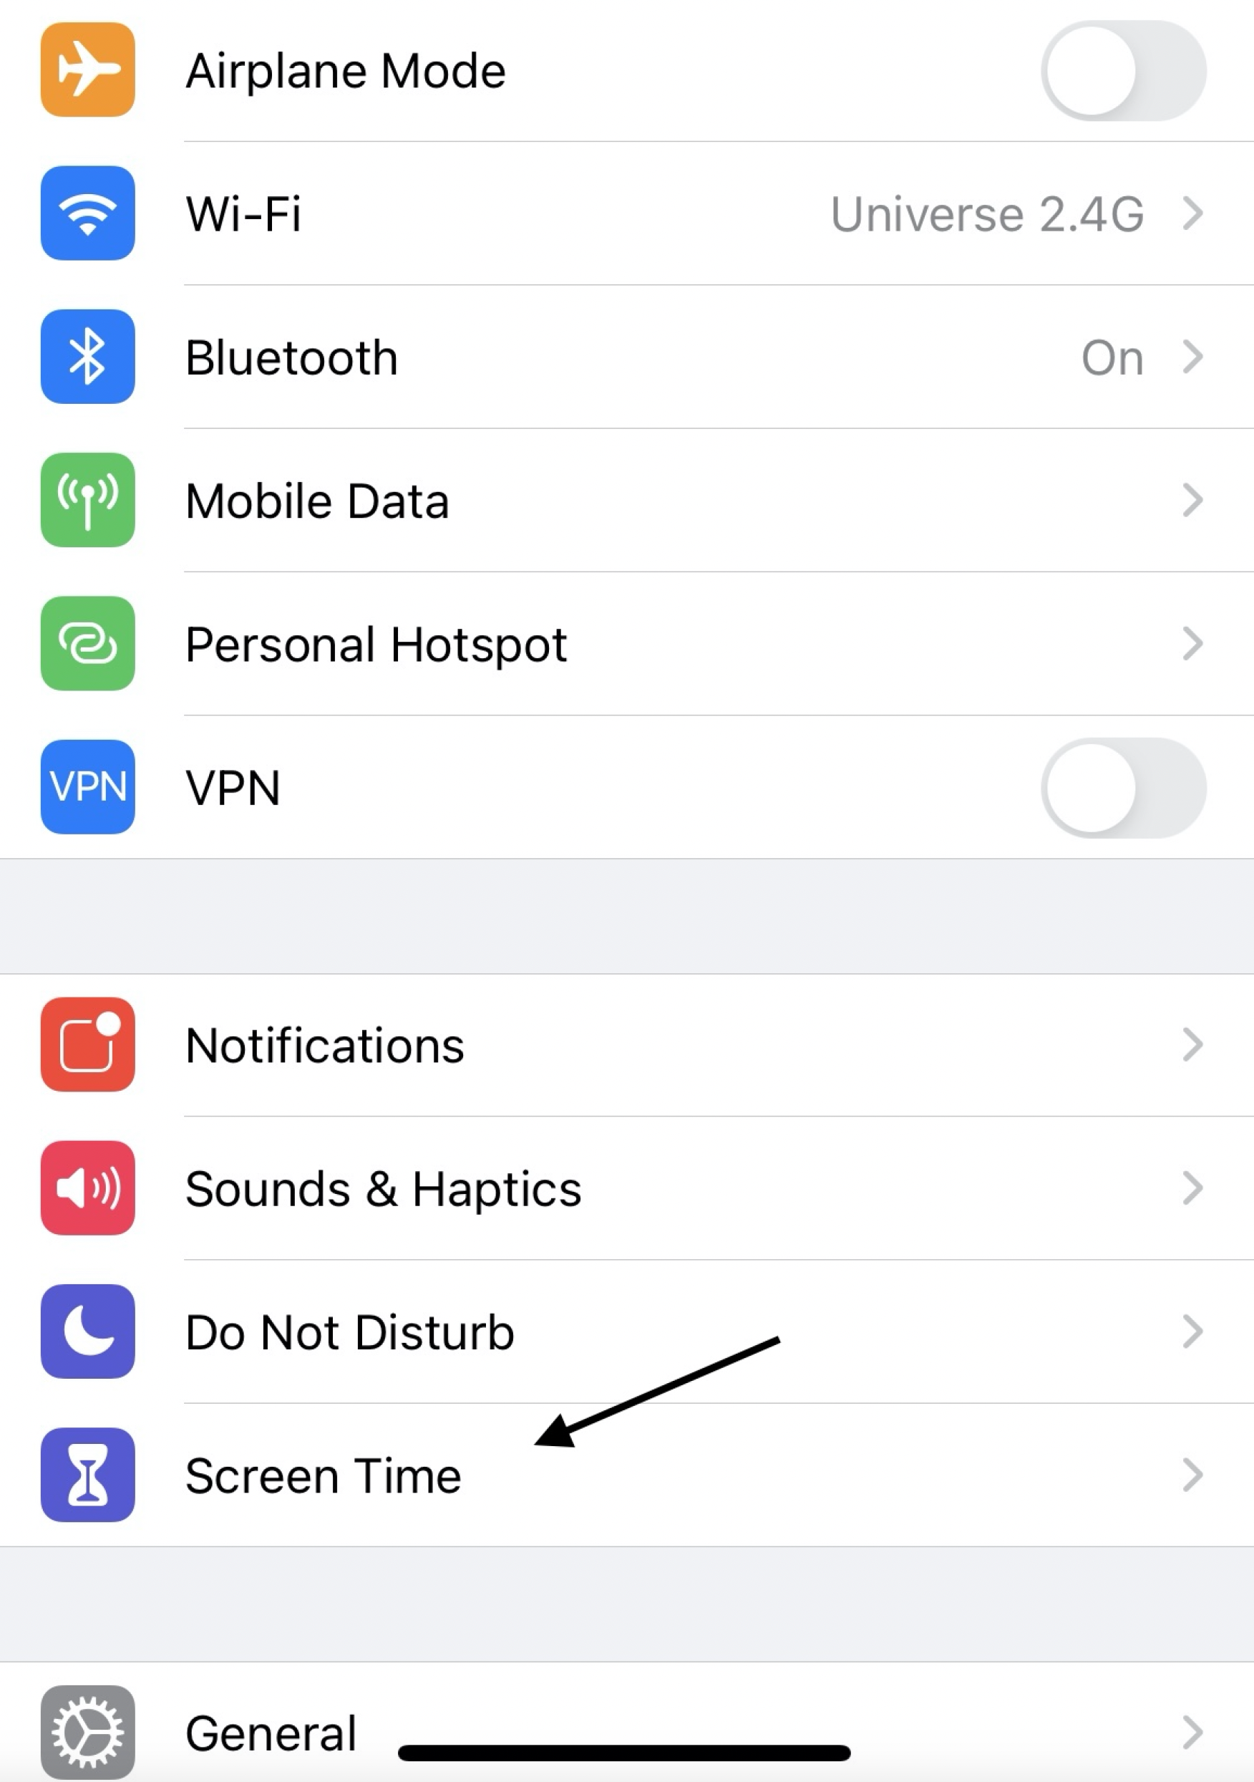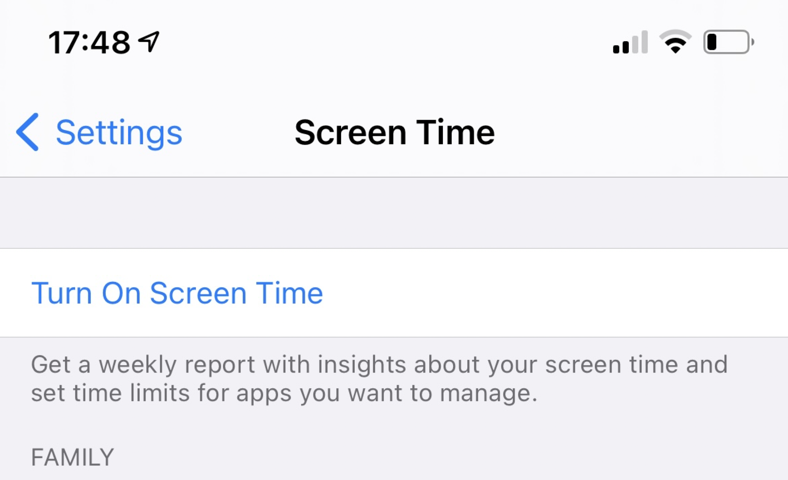

When you turn on Screen Time as above, you will be prompted whether it is for yourself or for a child’s device. You can then set a PIN which stops the child making any changes to what you set up and is also used for you to approve any time extensions/downloads etc.

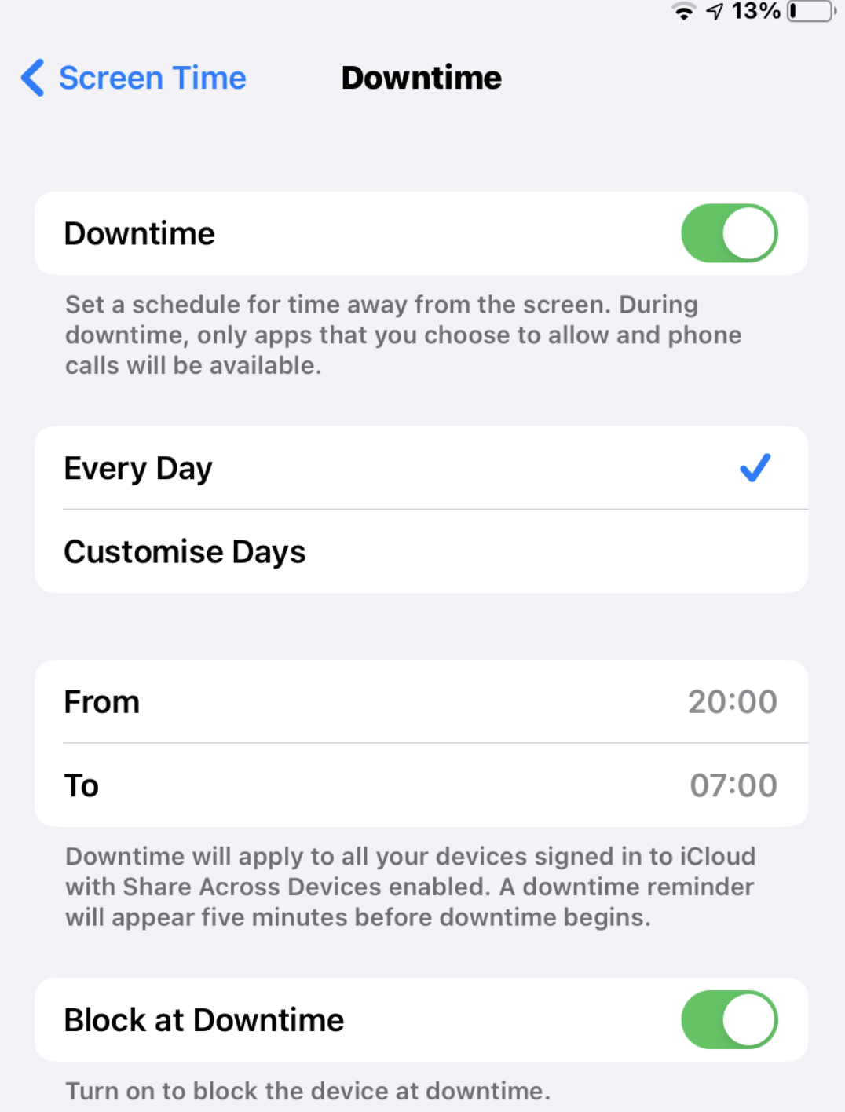 Make sure Block at Downtime is switched ON

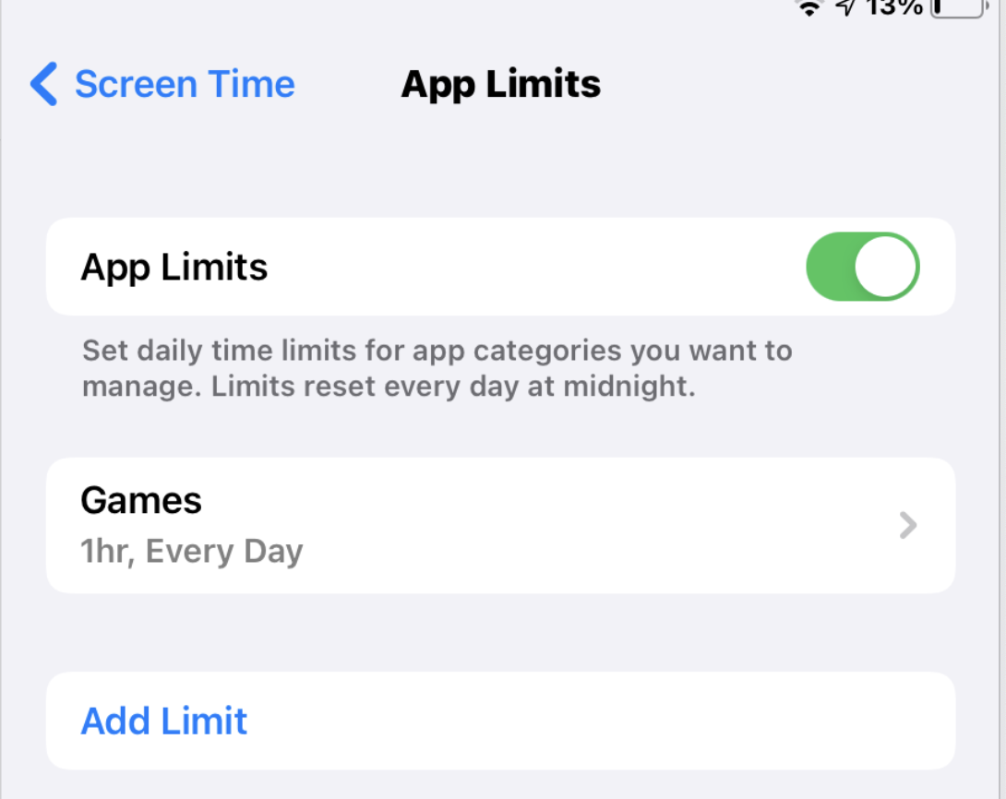 Enable App Limits and then Add Limit for any categories you wish to limit.

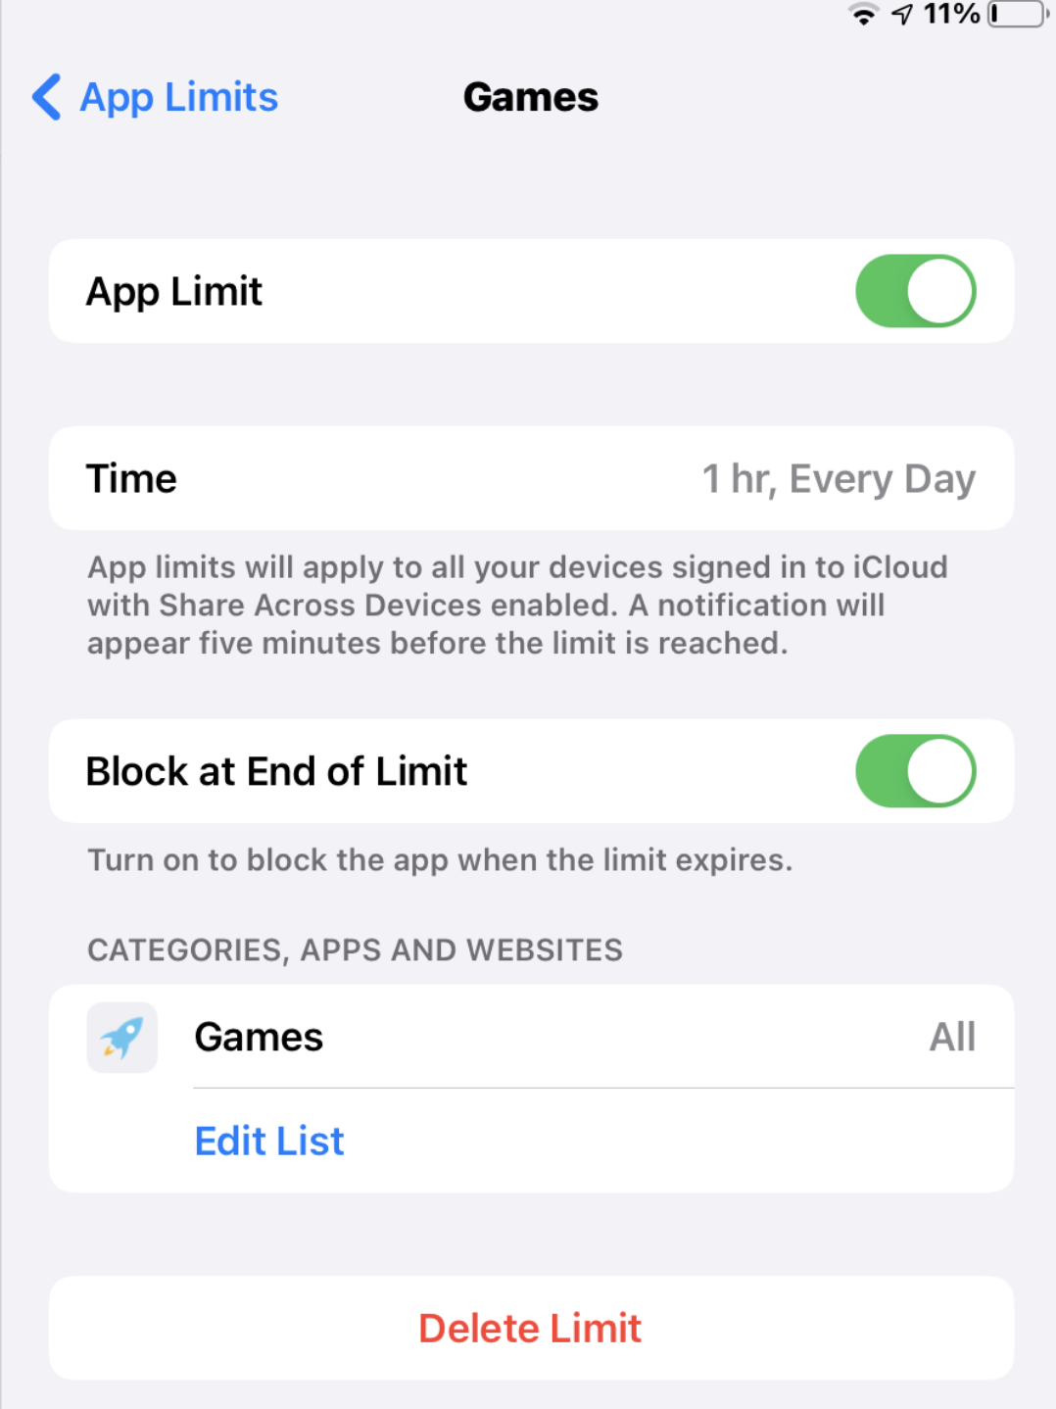 Ensure Block at End of Limit is switch ON otherwise children will be able to “Ignore Limit”.

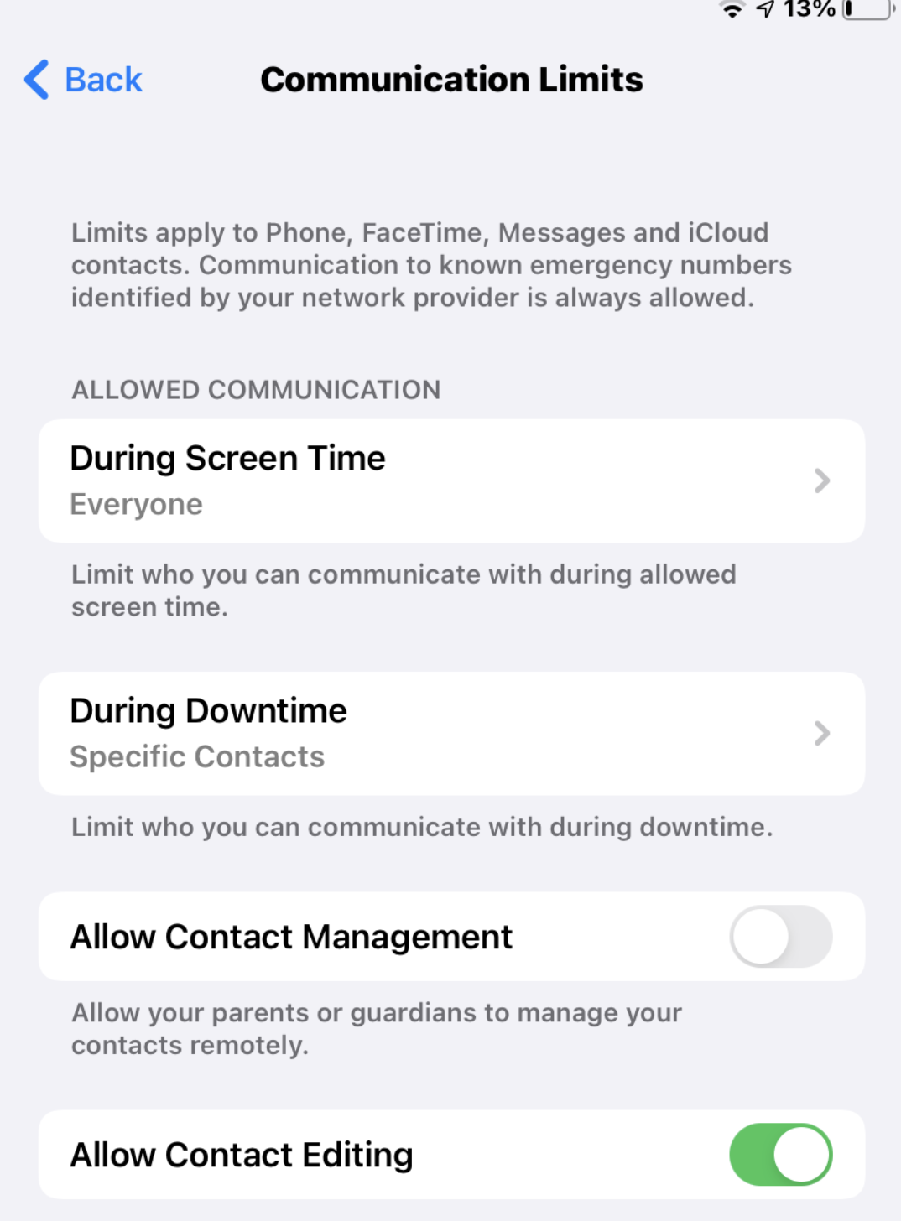 Communication Limits allow you to specify who children can contact during Downtime to ensure that they can always contact someone in an emergency.

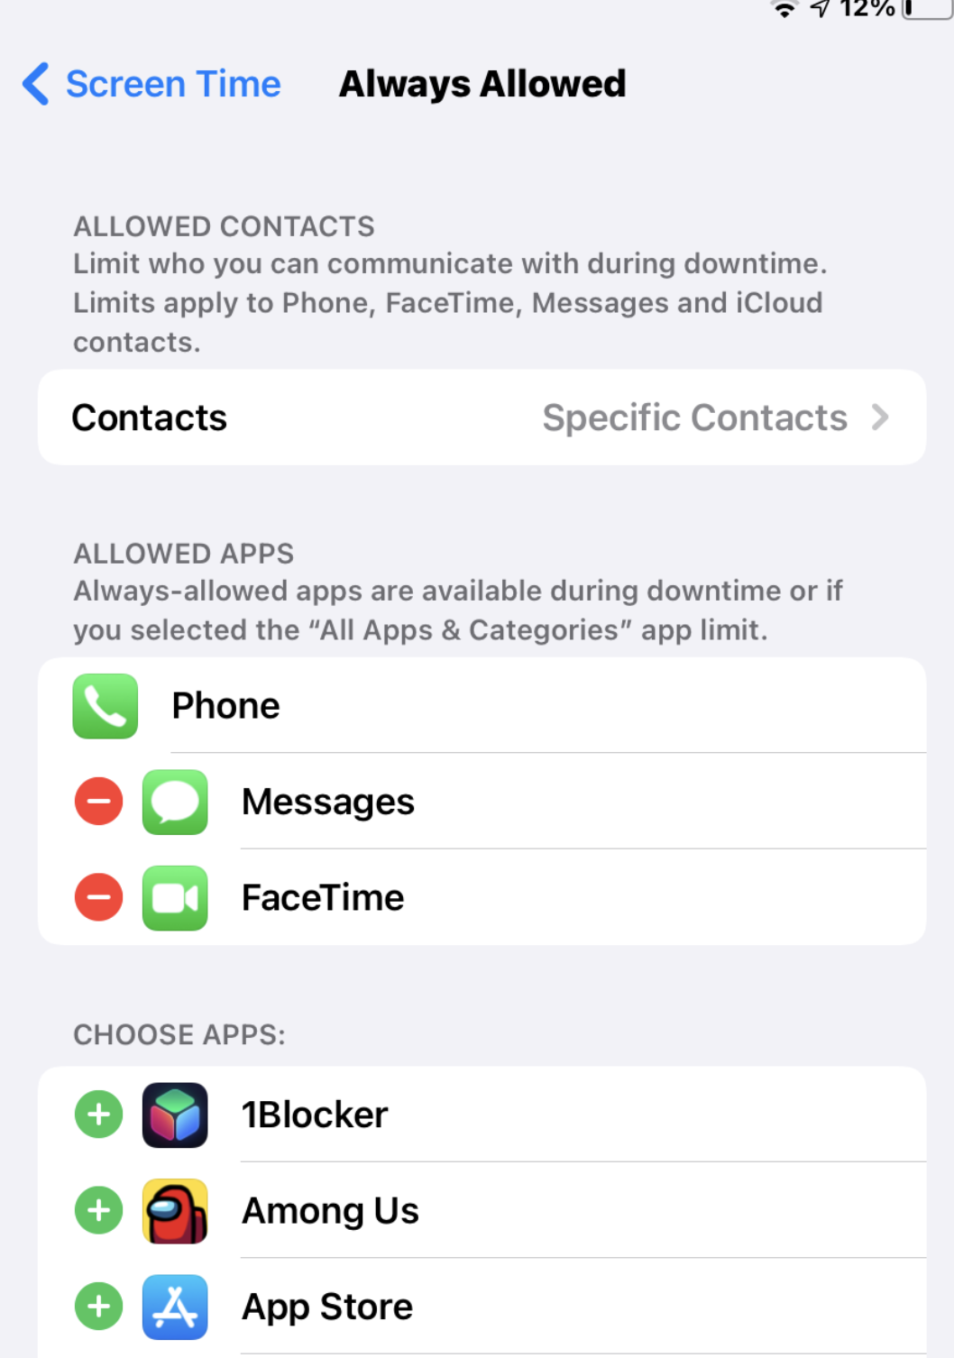 Manually add any apps you want children to always be able to use even during Downtime.. TT Rock Stars?! Messages, Phone and Facetime should be left on but subject to Downtime Specific Contacts.

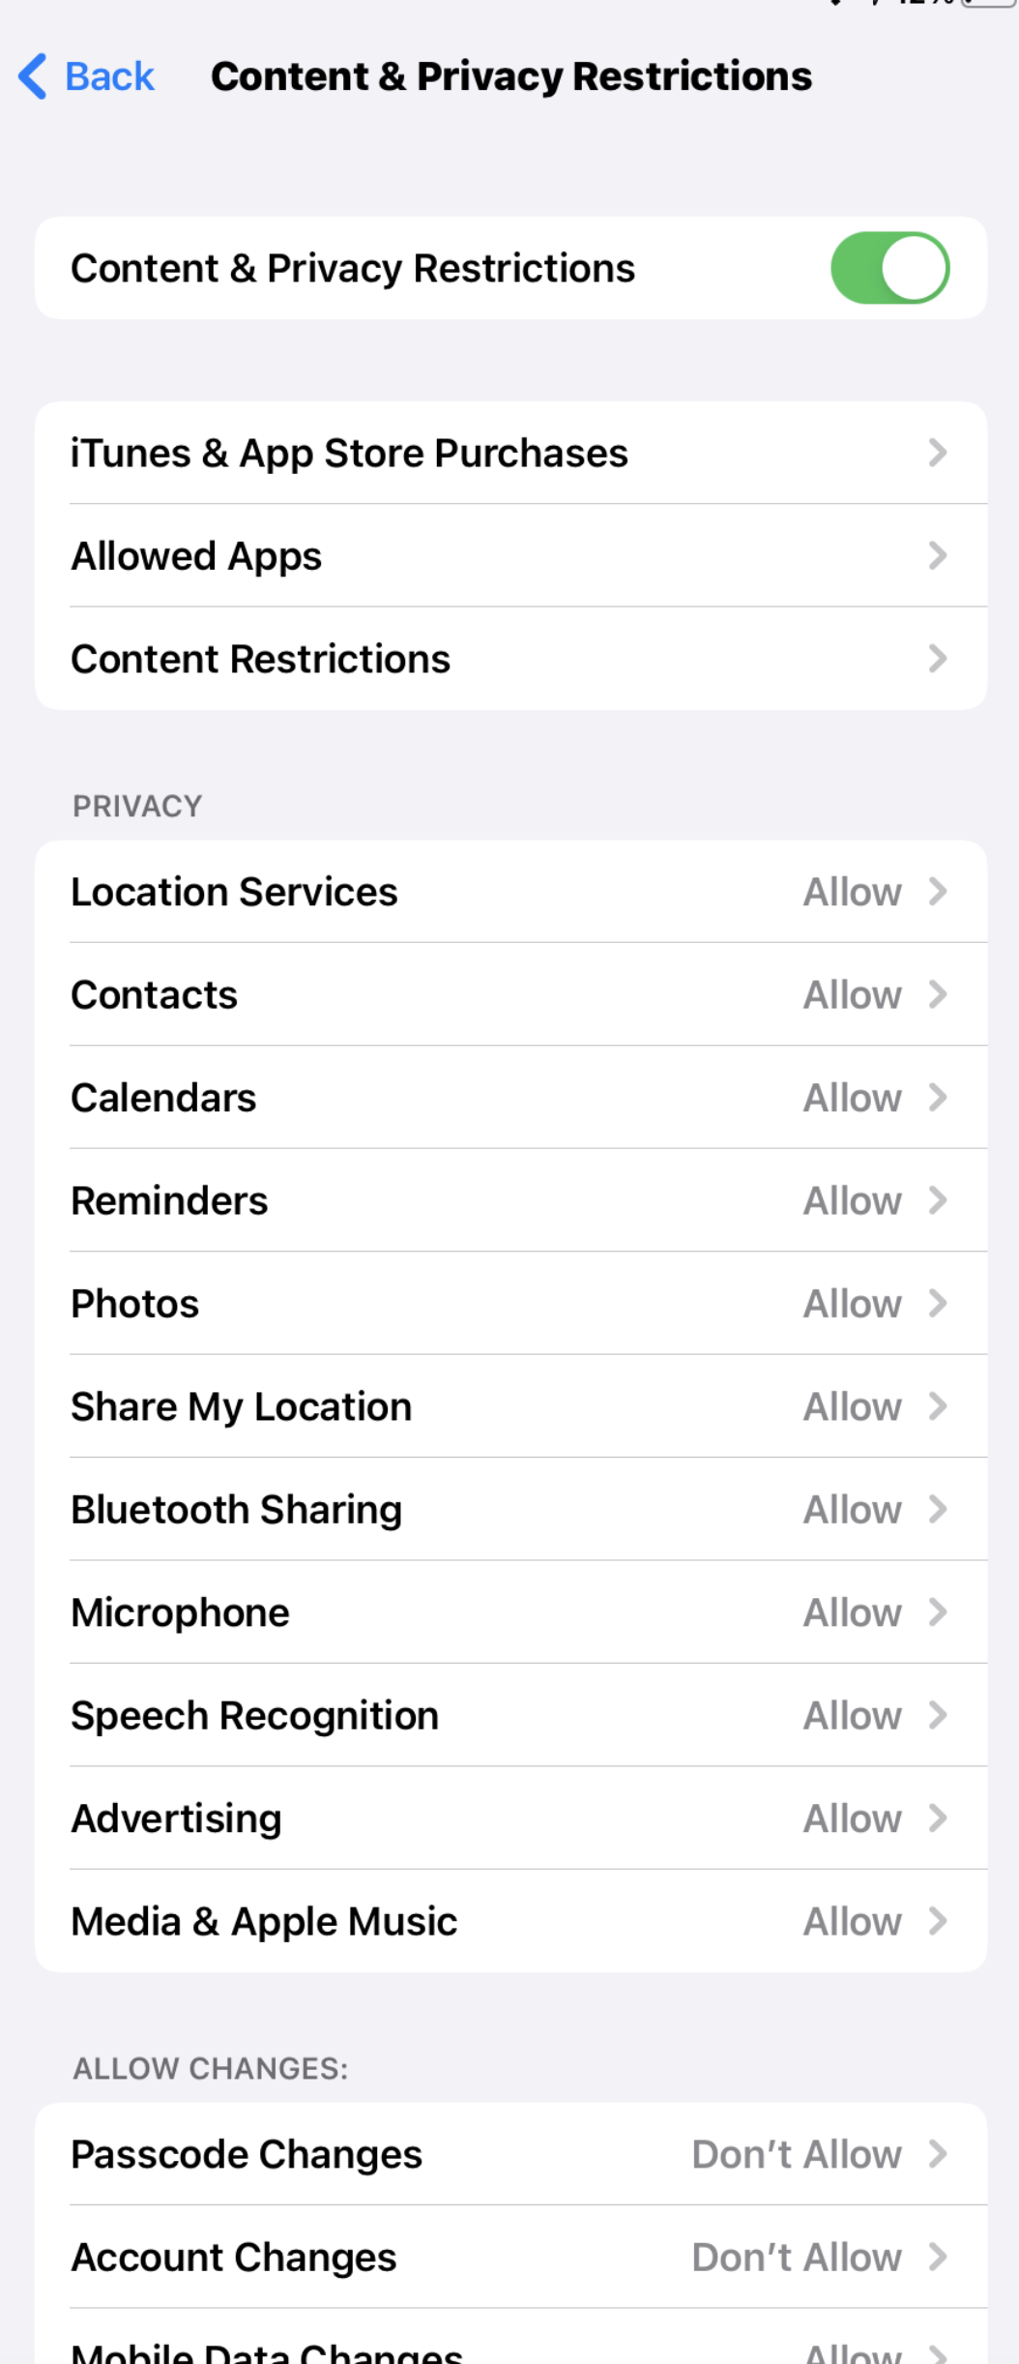 Content and Privacy Restrictions allows you to restrict access to Apple’s built-in services and to lock the phone so that changes can’t be made. E.g. Passcode can’t be changed so you can always access the device should you need to.

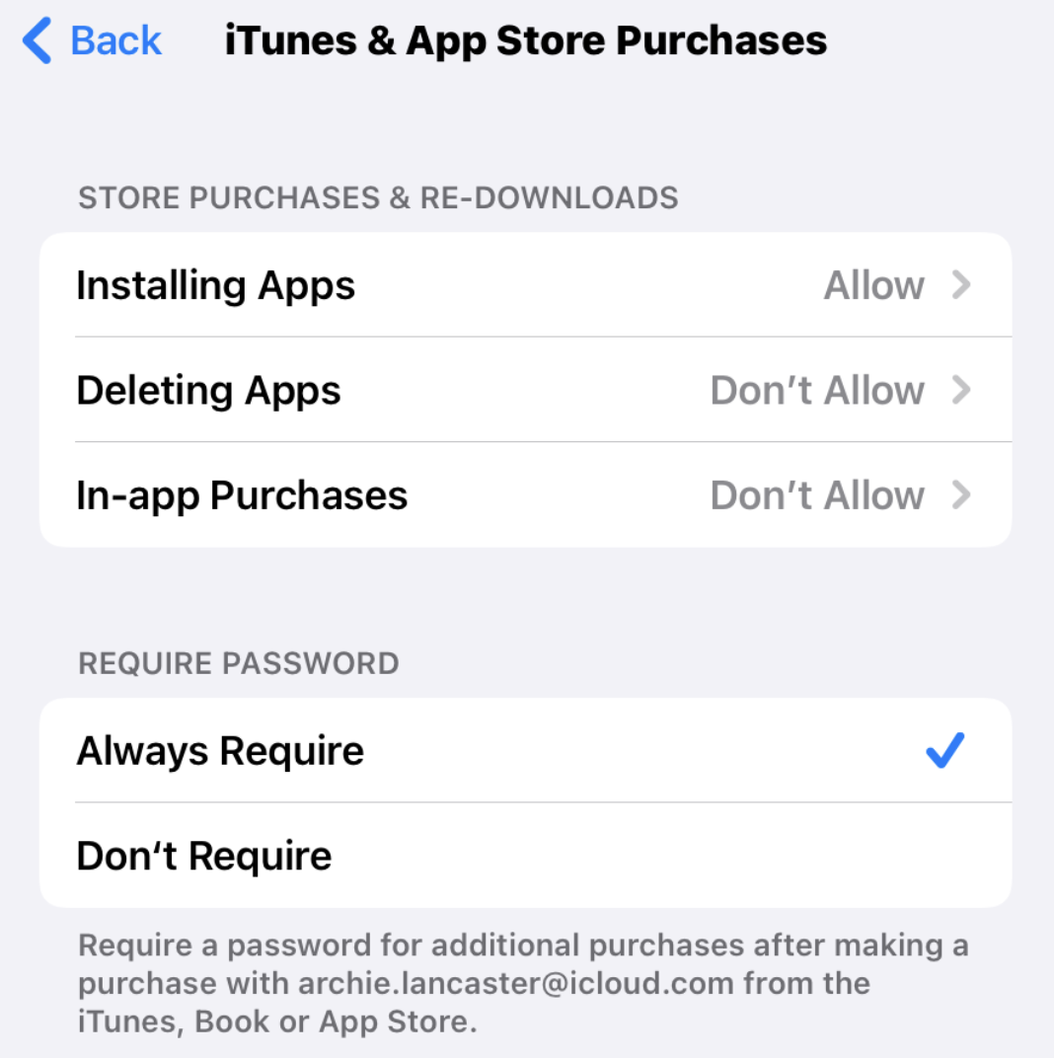 App Store Restrictions allows apps to be installed (subject to a request being sent), but in app-purchases, if they’re linked to a family payment means, can be blocked.

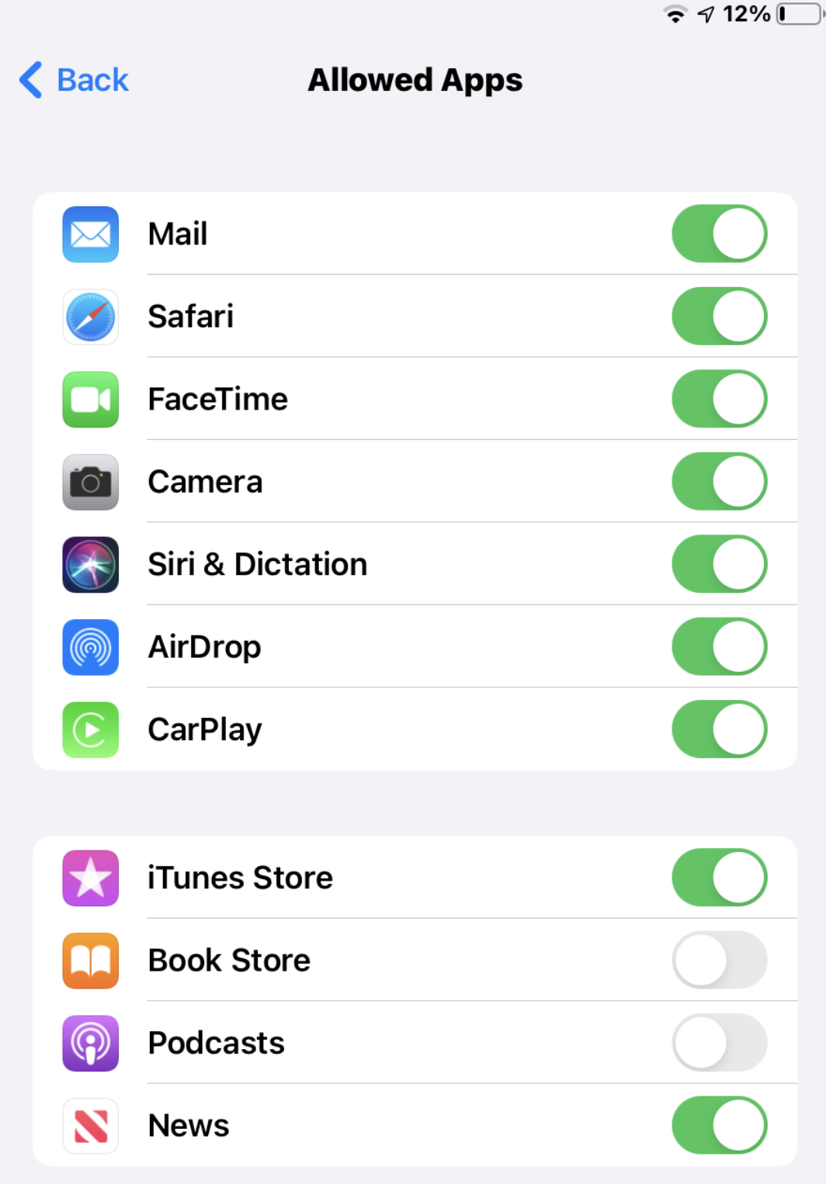 Allowed Apps allows specific Apple apps and functionality to be blocked if you wish.

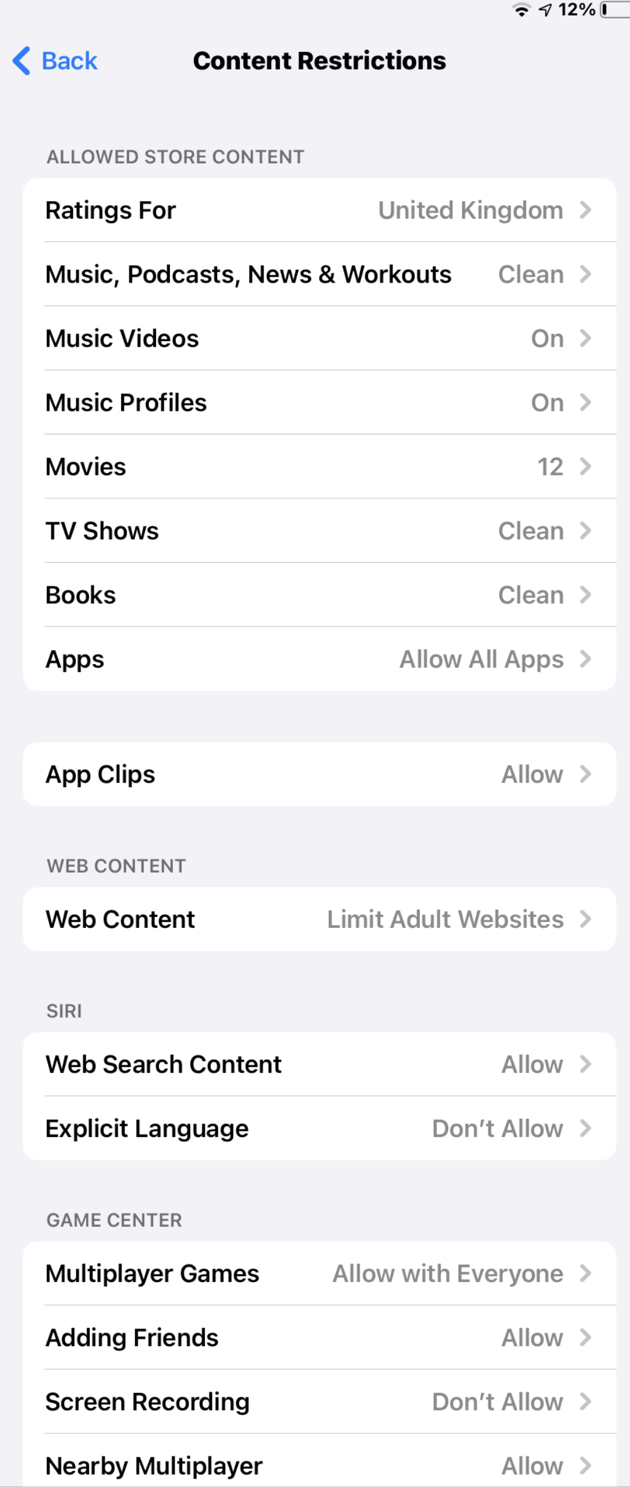 The Content Restrictions page contains lots of important settings for parents. The most important one is Web Content which should be set to “Limit Adult Websites”. Store content limits access to age-appropriate material, but only through Apple’s services.

Multiplayer games can be restricted only friends, but a lot of games don’t work within Apple’s Game Centre, so this isn’t always effective.

