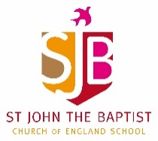
Home Learning – Week commencing 15th June 2020
Year 6
Use the links below to access videos and activities to complete each week.
Subject | Lessons / Resources | Notes
Maths  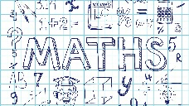 | White Rose – Summer Term Week 2 - Watch the video then complete the activity booklets.  https://whiterosemaths.com/homelearning/year-6/  - L1: Angles in special quadrilaterals  - L2: Angles in regular polygons  - L3: Problem Solving  - L4: Problem Solving  - L5: Maths Challenge  Due to starting these units later than published, we are going back to the start of the summer term’s schemes of work so please scroll down the page and open the tab for Week 2 – w/c 27th April. | Please complete learning from Week 2 – w/c 27th April  Please also continue to work through your CGP books.
English | Sentence Stackers – Belly Flop  https://www.youtube.com/watch?v=obLeGYVnyp4  Belly Flop:  https://www.youtube.com/watch?v=ls5J7caQj7A  Foci:  - relative clauses, who….,  - repetition  - sound effects  L1: Watch the Sentence Stackers video and Belly Flop video. Choose your ‘chunk’.  L2: Storyboard own chunk into 6 smaller parts and annotate.  L3: Draft your version of the story. Try to add at least one of the writing foci above. Re-watch original Sentence Stackers video to help.  L4: Re-read what you’ve written with someone. Can you find one thing to improve?  L5: Publish your work and illustrate as appropriate. | Please also continue to work through your CGP books.
Topic | Science – Light  Light Sources (45 minutes)  L1: What is light?  https://www.bbc.co.uk/bitesize/topics/zbssgk7/articles/z2s4xfr  Watch the video and write a definition of what a light source is. Create a table and list objects that are a light source / not a light source. Add own ideas to the table.  - Worksheet – Identifying Light Sources  L2: How do we see things? (45 minutes)  https://www.bbc.co.uk/bitesize/topics/zbssgk7/articles/zp7f8mn  https://www.bbc.co.uk/bitesize/clips/zf9c87h  Watch videos and read through the PowerPoint  - PowerPoint  - Worksheet – How Light Travels / How We See Things | Please also continue to work through your Science CGP books.
Art  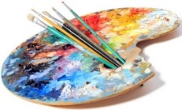 | Art – How Artists Portray Light in Paintings  L1: Light and Dark - Using pencils / charcoal  Read through the PowerPoint and watch the videos:  https://www.bbc.co.uk/bitesize/clips/zcqcjxs  https://www.bbc.co.uk/bitesize/clips/zxyxfg8  Have a go at the two activities (using either pencils or charcoal) – Drawing Texture and Shading Circles.  L2: Drawing Using Tone – Creating texture and shading  Read through the PowerPoint and watch video:  https://www.youtube.com/watch?v=TPEyJfkb1SE  Have a go at the activities – Tonal Shading and Tonal Shading Extension

