Tonal Shading
You will need: a pencil, a rubber and a sharpener
Using just an ordinary HB pencil, shade each box with the required tone, copying the box above.
Think about the pressure you apply with the pencil and the direction of your lines. You can also make your shading appear smoother by blending the pencil with your finger or the edge of a rubber.
Now try to use cross-hatching to achieve tone. Copy the direction of the lines in each box using a pencil.
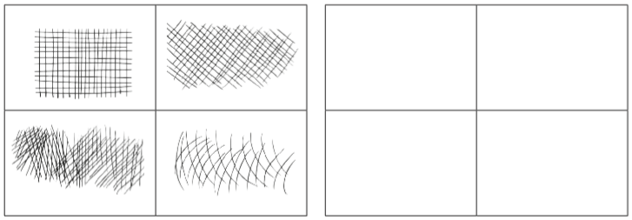
Using Tonal on a 3D Object
Your next task is to use tone to make an object appear 3D.
- Remember to shade in the direction of the shade.
- Use a rubber to achieve a highlight and a heavier pressure to achieve a shadow beneath the sphere.
- Think about where the light is shining on your object and where the shadow needs to be.

Example of a tonal shaded cube:  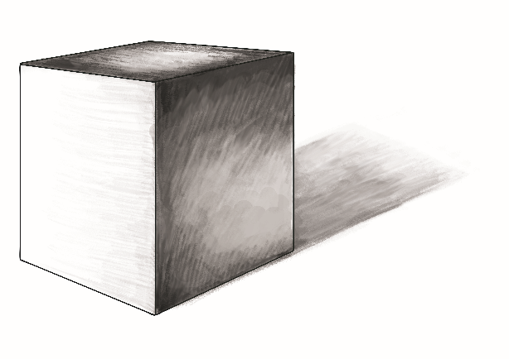 | Example of a tonal shaded sphere:
Now copy the shaded 3D shapes below:

