Tonal Shading
Now you have had a practice using tone and cross-hatching, your next task is to use either technique to add a range of tone, shadows and highlights to each template. Try and find the objects to draw from.
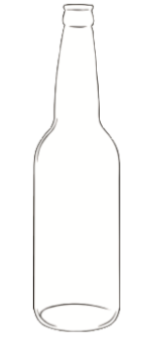 | 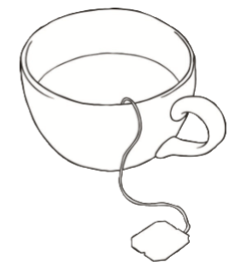
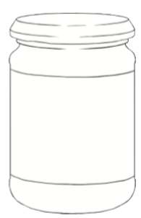 | Choose your own object to draw and shade

