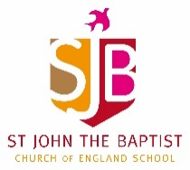
Home Learning – Week commencing 8th June 2020
Year 3
Use the links below to access videos and activities to complete each week.
Subject | Lessons / Resources | Notes
Maths  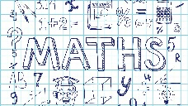 | White Rose – Summer Term Week 1  Watch the video then complete the activity booklet.  - L1: Equivalent Fractions 2  - L2: Equivalent fractions 3  - L3: Compare fractions  - L4: Order fractions  - L5: Maths Challenge  https://whiterosemaths.com/homelearning/year-3/ | Please complete learning from Week 1 – w/c 20 April
English | Retell story of “While we can’t hug” (available on the school website)  - L1: Read the story and discuss favourite ways to show you care without hugging from the story / other.  - L2: Draw your own pictures for four examples.  - L3: Write a paragraph for each picture.  - L4: Share your story with someone else.  - L5: Write a letter from the hedgehog to the tortoise, sharing your ideas. | Try creating your own little book.
Topic | Blue Planet  Oceans and seas.  - L1: Use google earth to help you identify different oceans and seas. Create your own map.  Label the following:  - Pacific Ocean  - Atlantic Ocean  - Indian Ocean  - Mediterranean Sea  - Southern Ocean  - Red Sea  - Caribbean Sea  - Aegean Sea  - Arctic Ocean  - L2: Add facts to your map – what can you find out? Find the most interesting fact you’ll think no one else will know.
Art | - L1: Look at images of sea creatures – note down what you notice; the colours, shapes and textures. Group creatures according to these criteria.  - L2: Have a go at drawing your own sea creature. Look closely at the shading of your creature. Can you create shading effects using your pencil? Use the guide to help you. | Take pics of your artwork and email: office@st-john.hackney. sch.uk

