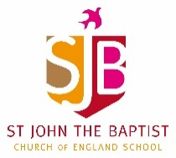
Home Learning – Week commencing 15th June 2020
Year 2
Use the links below to access videos and activities to complete each week.
Subject | Lessons / Resources | Notes
Maths  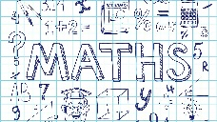 | White Rose – Summer Term Week 2  Watch the video then complete the activity booklets.  https://whiterosemaths.com/homelearning/year-2/  - L1: Compare lengths  - L2: Order lengths  - L3: Four operations with length  - L4: Problem solving  - L5: Maths Challenge  Due to starting these units later than published, we are going back to the start of the summer term’s schemes of work so please scroll down the page and open the tab for Week 2 – w/c 27th April. | Please complete learning from Week 2 – w/c 27th April
English | Talk4Writing –Rainbows, rainbows everywhere!  https://www.talk4writing.com/wp-content/uploads/2020/05/Y2-Rainbows.pdf  L1: Talking about rainbows p2-4  L2: Reading information text and questions p5-7  L3: Reading Challenge and create own explanation text template p9-10  L4: Writing Challenge plan p11-12  L5: Writing Challenge write p13-14  Feel free to complete other activities from the pack too! | Please see pack for instructions.
Topic | Blue Planet  Oceans and seas.  - L1: Oceans are made up of different zones.  Draw a picture to show the names of each of these zones:  Sunlight zone  Twilight Zone  Midnight Zone  Abyss  Trench  Next week, we’ll be looking at creatures that live there too!  - L2: Read pages 5/6 of the Ocean layers quiz and answer the questions on p7. | There is a pdf information pack available on the school website to help here.
Art | - L1: Now you’ve drawn your sea creature, experiment with colour. What colours can you mix to make others?  Create a colour mixing chart to show what you’ve found out.  - L2: Use pencil, paint, collage or whatever materials you have at home to create a colourful sea creature. You can finish your one from last week or draw another.

