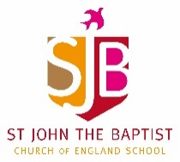
Home Learning – Week commencing 8th June 2020
Year 1
Use the links below to access videos and activities to complete each week.
Subject | Lessons / Resources | Notes
Maths  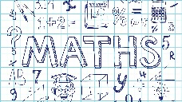 | White Rose – Summer Term Week 1  Watch the video then complete the activity booklet.  - L1: Make doubles  - L2: Make equal groups (grouping)  - L3: Make equal groups (sharing)  - L4: Find a half  - L5: Maths Challenge  https://whiterosemaths.com/homelearning/year-1/ | Please complete learning from Week 1 – w/c 20 April
English | Retell story of “While we can’t hug” (available on the school website)  - L1: Read the story and discuss favourite ways to show you care without hugging from the story / other.  - L2: Draw your own pictures for three examples.  - L3: Write sentences for each picture.  - L4: Share your story with someone else.  - L5: Write a letter from the hedgehog to the tortoise, sharing your ideas.
Topic | Blue Planet  Oceans and seas.  - L1: Use google earth to help you identify different oceans and seas. Can you create your own map?  Label the following:  - Pacific Ocean  - Atlantic Ocean  - Indian Ocean  - Mediterranean Sea  - Southern Ocean  - Red Sea  - Caribbean Sea  - L2: Add facts to your map – what can you find out?  https://www.dkfindout.com/uk/earth/oceans-and-seas/
Art | - L1: Look at images of sea creatures – note down what you notice; the colours, shapes and textures.  - L2: Have a go at drawing your own sea creature. Look closely at the shape of your creature.  If you can, take a picture of your art work and send to the school office so we can put it up on Instagram / twitter:  Office@st-john.hackney.sch.uk

