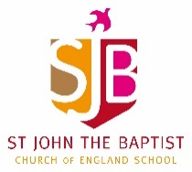
Home Learning – Week commencing 15th June 2020
Year 1
Use the links below to access videos and activities to complete each week.
Subject | Lessons / Resources | Notes
Maths  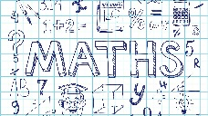 | White Rose – Summer Term Week 2  Watch the video then complete the activity booklets.  https://whiterosemaths.com/homelearning/year-1/  - L1: Find a half (2)  - L2: Find a quarter (1)  - L3: Find a quarter (2)  - L4: Problem Solving  - L5: Maths Challenge  Due to starting these units later than published, we are going back to the start of the summer term’s schemes of work so please scroll down the page and open the tab for Week 2 – w/c 27th April. | Please complete learning from Week 2 – w/c 27th April
English | Talk4Writing - Sayeeda, the Pirate Princess  https://www.talk4writing.com/wp-content/uploads/2020/05/Y1-Sayeeda.pdf  L1: Story of Sayeeda the pirate princess - Talk activity about the story  L2: Reading response activities: - Who said what? - Quiz Time  L3: Fill your treasure chest  L4: Sayeeda’s diary entry: helping her to use full stops and capital letters  L5: Storytime – Fergus’ adventure | Please see pack for instructions.
Topic | Blue Planet  Oceans and seas.  - L1: Oceans are made up of different zones.  Draw a picture to show the names of each of these zones:  Sunlight zone  Twilight Zone  Midnight Zone  Abyss  Trench  Next week, we’ll be looking at creatures that live there too!  - L2: Read the first two pages of the Ocean layers quiz and answer the questions. | There is a pdf information pack available on the school website to help here.
Art | - L1: Now you’ve drawn your sea creature, experiment with colour. What colours can you mix to make others?  Create a colour mixing chart to show what you’ve found out.  - L2: Use pencil, paint, collage or whatever materials you have at home to create a colourful sea creature. You can finish your one from last week or draw another.

